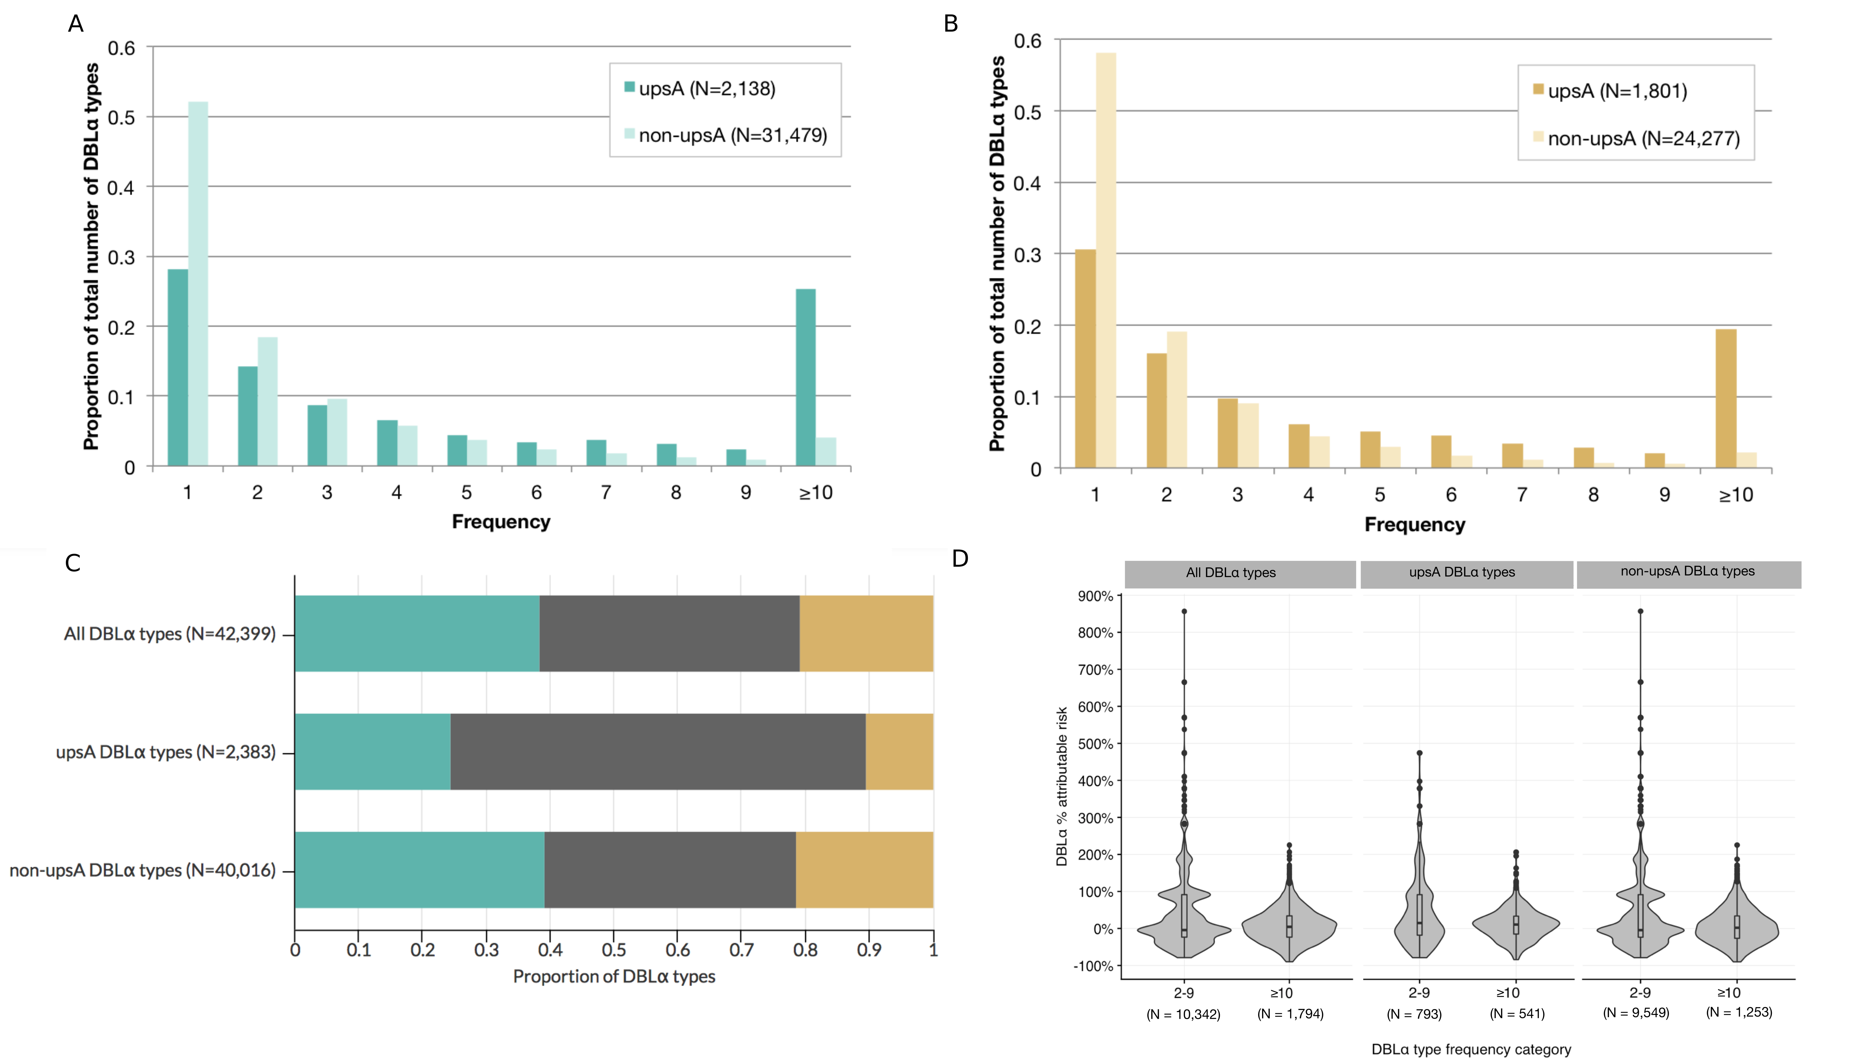

**Figure 1. DBLα type-specific seasonal patterns (A-B)** Frequency distribution of upsA and non-upsA DBLα types **A.** at the end of the wet season (EWS) and **B.** at the end of the dry season (EDS). N refers to the total number of unique DBLα types sequenced. The proportion of upsA DBLα types in the abundant category was significantly greater compared to non-upsA DBLα types (*p* < 0.001 EWS, EDS). Specifically, the upsA DBLα types were ~8x and ~11x more likely to be in the abundant category compared to the non-upsA DBLα types at the EWS and EDS, respectively. **(C) The maintenance of DBLα types in the population between seasons.** Proportion of unique DBLα types identified at the end of the wet season (blue), at the end of the dry season (tan) and found in both seasons (i.e., maintained) (grey). N refers to the total number of unique DBLα types sequenced. We found that 17,296 DBLα types out of the 42,399 total DBLα types (when both seasons were combined) were maintained. An additional 16,321 and 8,782 were observed only at the EWS and EDS, respectively. Interestingly, of the 1,801 upsA DBLα types identified at the EDS, 86.4% were also observed during the preceding EWS. **(D)** **Seasonal changes in prevalence of maintained DBLα types.** Violin plots showing the distribution of percent attributable risk (%AR) values for each intermediary and abundant maintained DBLα type (N=17,296) from the EWS to the EDS. The calculation was performed as follows: %AR = ((NEWS -NEDS)/ NEWS) * 100, where NEWS is equal to the prevalence of a DBLα type at the EWS and NEDS is equal to its prevalence at the EDS. Prevalence was calculated based on the total number of DBLα sequences sampled at the end of each season (N = 110,596 EWS, N = 57,821 EDS). DBLα types that were rare at the EWS are not included in the figure (see Supp).

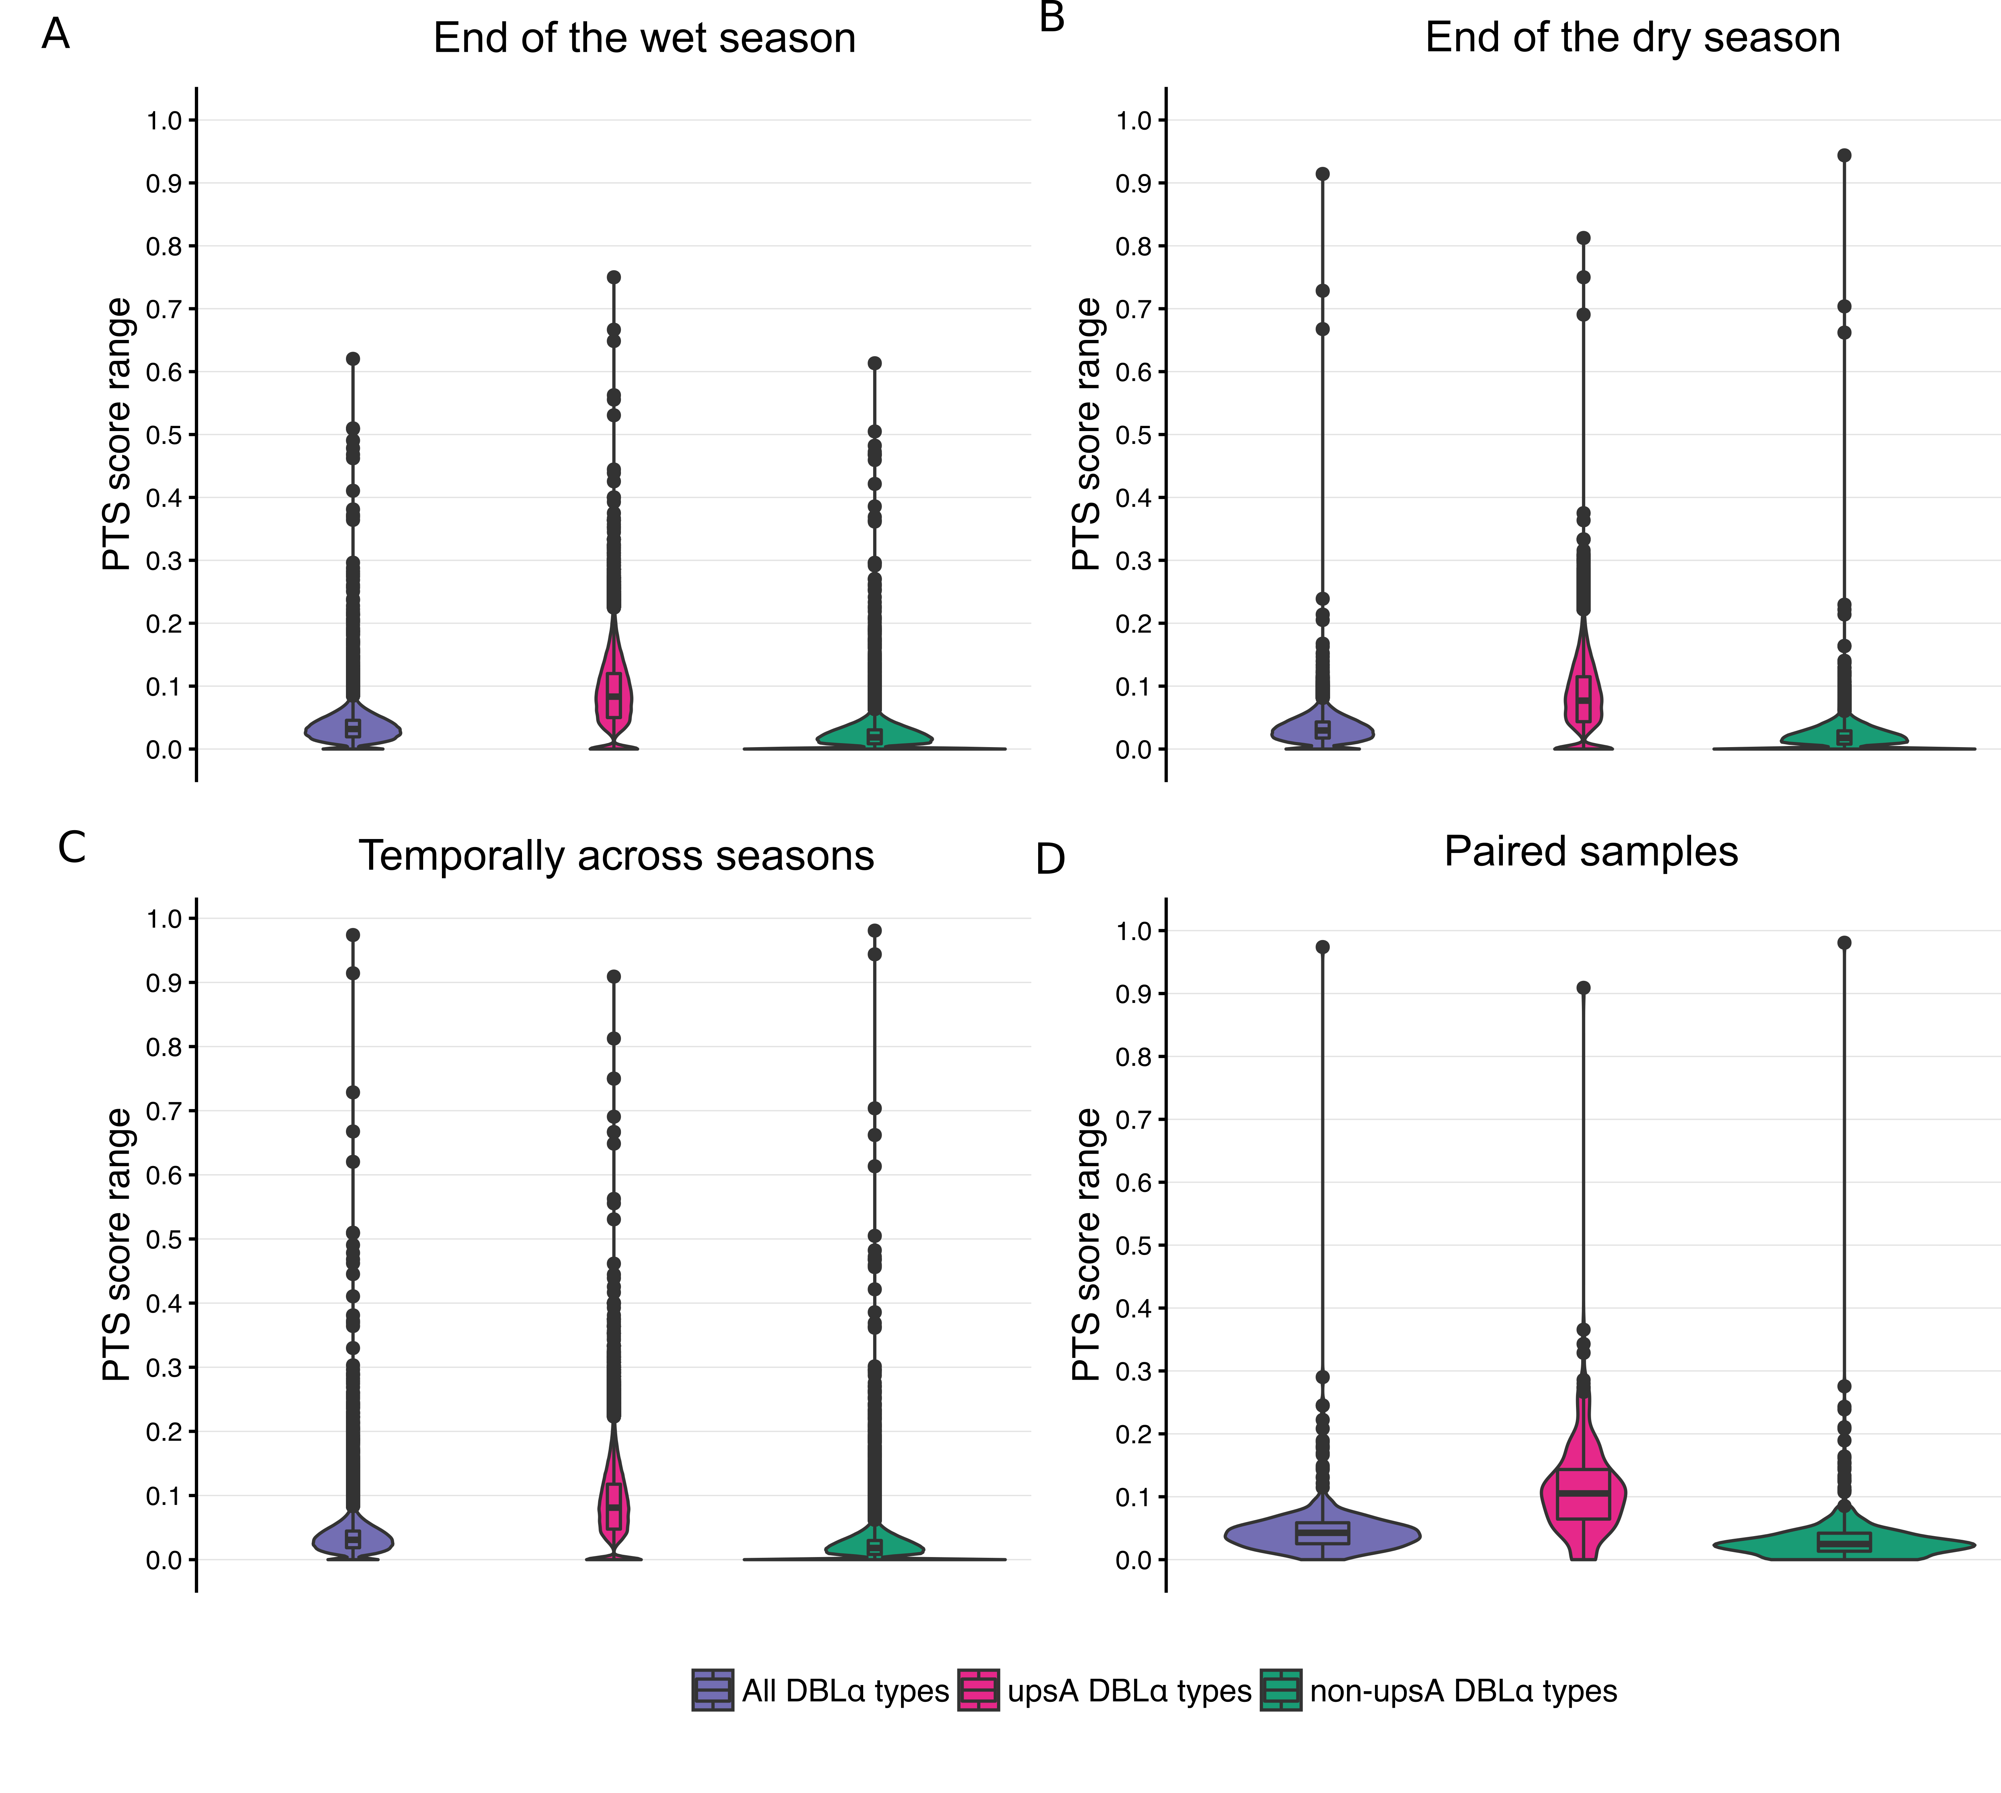

**Figure 2. Patterns of pairwise type sharing and repertoire overlap.** Violin plots show the distribution of pairwise type sharing (PTS) scores among isolate DBLα repertoires. The colors indicate the distribution of PTS scores among isolate DBLα repertoires for all DBLα types (purple), upsA DBLα types (pink) and non-upsA DBLα types (green). **(A)** At the end of the wet season (EWS) the median PTS score was 0.03 (range = 0 – 0.62) with three highly-related isolate pairs (PTS ≥ 0.50) identified, which are represented by points on the violin plot. **(B)** At the end of the dry season (EDS) the median PTS score was 0.03 (range = 0 – 0.91) with three highly-related isolate pairs identified. **(C)** To examine the *temporal* patterns of population structure across transmission seasons, we calculated PTS by comparing the 664 isolate repertoires at the EWS to the 435 isolate repertoires at the EDS. We observed minimal overlap of DBLα repertoires between seasons; the median PTS was 0.03 (range = 0 - 0.97) and 99.9% of isolate repertoires shared ≤10% of their DBLα types (i.e., PTS ≤ 0.10). There was only one pair of identical isolate DBLα repertoires (PTS = 0.97), which curiously were identified from the same individual at both time points. **(D)** As a proportion of the cohort participants surveyed had asymptomatic infections (microscopic or submicroscopic) at both time points, we looked at the PTS in parasite isolates collected from the same individuals to look at temporal within-host infection turnover patterns. 575 individuals had asymptomatic infections at both the EWS and EDS and we were able to examine 296 of these individuals (*N* = 592 *P. falciparum* isolates) with *var* data at both time points for our analysis (see Supplement for details). The median PTS was 0.04 (range = 0 - 0.97) and 92.6% of isolate repertoires shared ≤10% of their DBLα types between seasons. The maximum PTS score (PTS = 0.97) revealed a chronic infection that persisted from the EWS through to the subsequent EDS for at least 7 months. When we examined the type-specific PTS patterns, there was significantly higher sharing of upsA DBLα types compared to the non-upsA types (*p* < 0.001) for all stratifications.



**Figure 3. Age-specific patterns of infection complexity and repertoire overlap. (A) Age-specific patterns of infection complexity.** Box and whisker plots depicting the number of DBLα types per *P. falciparum* isolate repertoire (i.e., isolate DBLα repertoire size) by host age group for isolates at the end of the wet season (blue) and at the end of the dry season (tan). The black dots indicate outliers and the minimum number of DBLα types was always 20 due to the removal of isolates with low DBLα sequence coverage (see Supplementary Methods and Figure SX for details on the criteria for removal). There were significant differences in the distribution of DBLα repertoire size across age groups in both seasons (*p* < 0.001, EWS, EDS). There was no significant difference in the distribution of repertoire sizes between seasons (*p* = 0.096). The proportion of complex infections remained high across all host age groups at the end of both seasons. **(B-D) Age-specific patterns of repertoire overlap among individuals within the same age group.** Violin plots show the distribution of pairwise type sharing (PTS) scores among isolate DBLα repertoires considering only single-genome infections **(B-C)** and all infections (single-genome and complex) **(D-E)**. Comparisons among individuals at the end of the wet and dry season are presented in blue (B, D) and tan (C,E), respectively. The inset diagonal depicts the pairwise comparisons of PTS score distributions among the different age groups (e.g., 1-5 year olds compared to 6-10 year olds). The color key provided corresponds to the *p* value for each pairwise comparison where white indicates a non-significant *p* value (≥0.05) and the color gradient (blue for end of wet season, tan for end of dry season) represents significant *p* values.

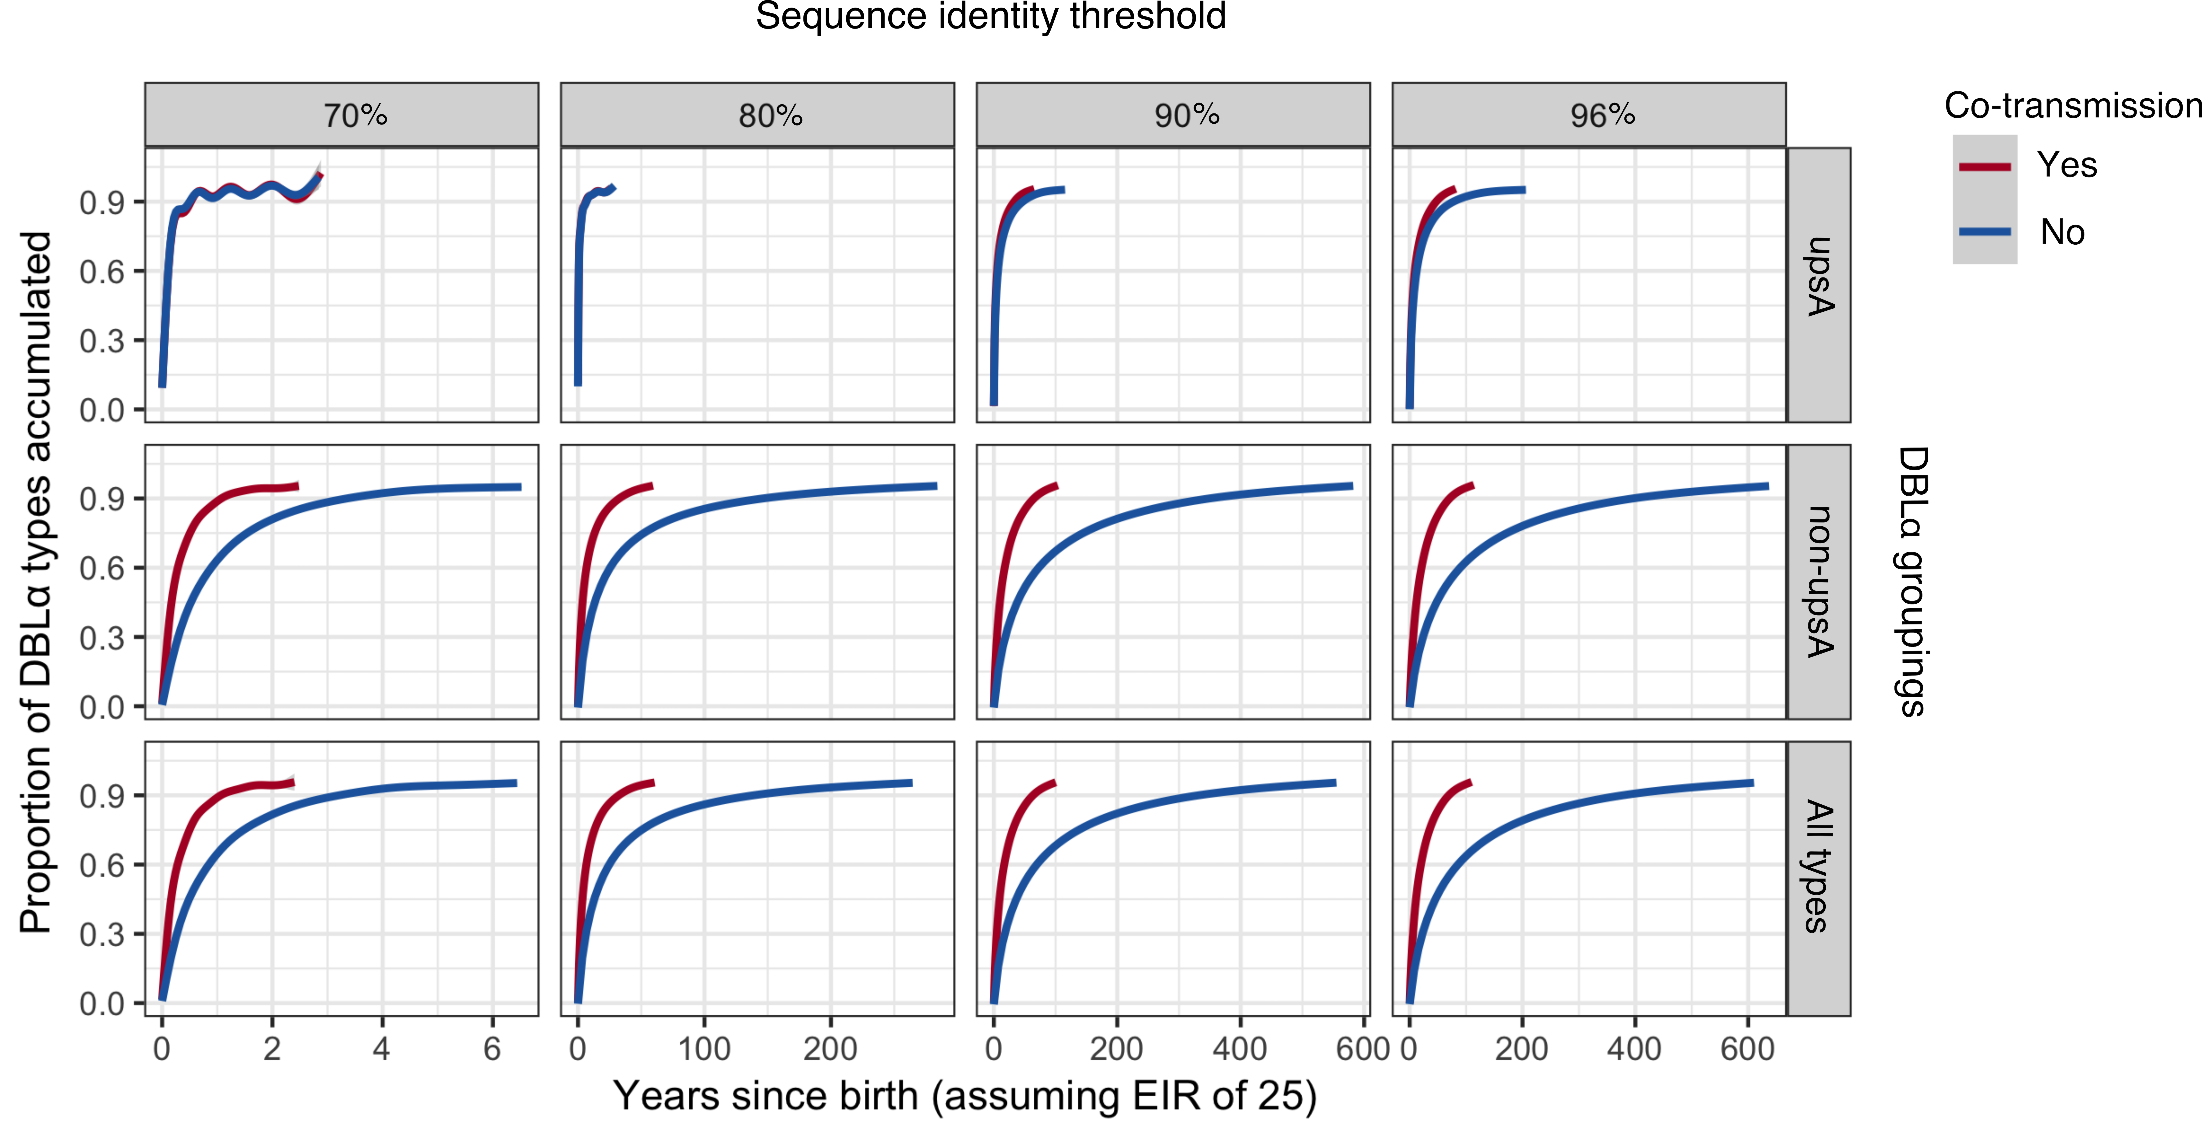

**Figure 4. Patterns of acquisition of immunity to DBLα types in Bongo.** Accumulation curves showing a lower (blue) and upper (red) bound for the time it takes an individual to acquire immunity to 95% of upsA DBLα types (top panel),non-upsA DBLα types (middle panel) and all DBLα types (lower panel) based on an annual EIR of 25. The lower bound (blue) is calculated by assuming a mosquito can transmit only single-genome infections (i.e., no co-transmission, MOI = 1) and the upper bound (red) is calculated by assuming a mosquito can transmitsingle-genome and/or complex infections (MOI ≥ 1) with each infectious bite (i.e., allowing for co-transmission) (see Supplementary Methods for case definitions and details on the simulation experiment). The DBLα types were defined at various sequence identity thresholds to test the effect of varying DBLα pool sizes on the accumulation curve patterns (i.e., a lower number of DBLα types would be identified at lower sequence identity thresholds resulting in a smaller overall DBLα pool size). From left to right, DBLα types were defined at 70%, 80%, 90% and 96% sequence identity. It is important to note that the *x* axes scales are different in the four panels. As an illustrative example, at 96% sequence identity and allowing for co-transmission, it would take ~5, ~12 and ~12 years for an individual to acquire immunity to 50% of the upsA DBLα types, non-upsA DBLα types and all DBLα types, respectively. In contrast, at 80% sequence identity and allowing for co-transmission, it would take ~1, ~4, ~4 years for an individual to acquire immunity to 50% of the upsA, non-upsA and all DBLα types, respectively. Interestingly, at 80% sequence identity, it would take ~30 years for an individual to acquire immunity to 95% of all upsA DBLα types regardless of whether we allowed for co-transmission.